QUICK SORT
- It uses the idea of divide and conquer approach.
- Quick Sort follows a recursive algorithm.
- It divides the given array into two sections using a partitioning element called as pivot.

The division performed is such that-
- All the elements to the left side of pivot are smaller than pivot.
- All the elements to the right side of pivot are greater than pivot.
- After dividing the array into two sections, the pivot is set at its correct position.
- Then, sub arrays are sorted separately by applying quick sort algorithm recursively.
- It is based on the splitting of an array (partition) into smaller ones and swapping (exchange) based on the comparison with 'pivot' element selected.
- Due to this, quick sort is also called as "Partition Exchange" sort.
Technically, quick sort follows the below steps:
Step 1 − Make any element as pivot
Step 2 − Partition the array on the basis of pivot
Step 3 − Apply quick sort on left partition recursively
Step 4 − Apply quick sort on right partition recursively
- Quick sort works by partitioning a given array A[p ... r] into two non-empty sub array
- A[p ... q] and A[q+1 ... r] such that every key in A[p ... q] is less than or equal to every key in A[q+1 ... r].
- Then, the two sub-arrays are sorted by recursive calls to Quick sort.
- The exact position of the partition depends on the given array and index q is computed as a part of the partitioning procedure.
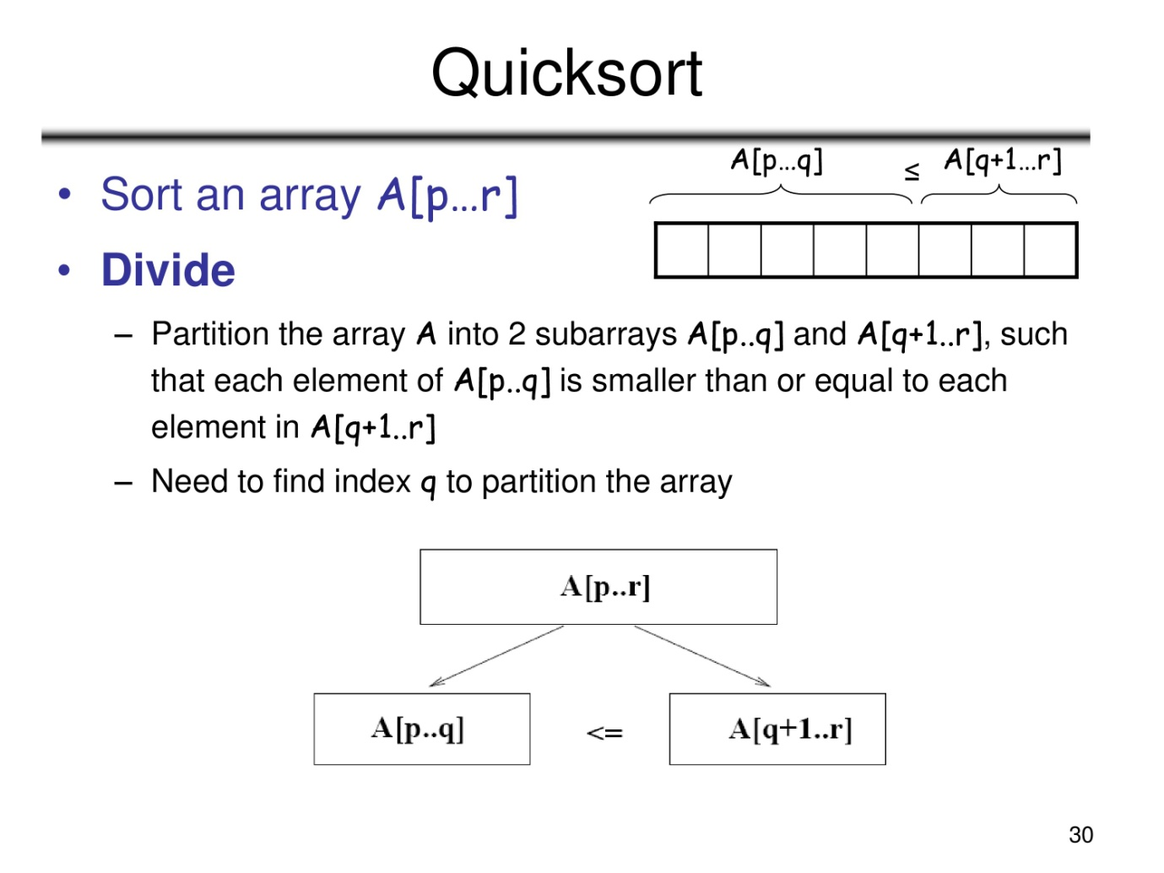
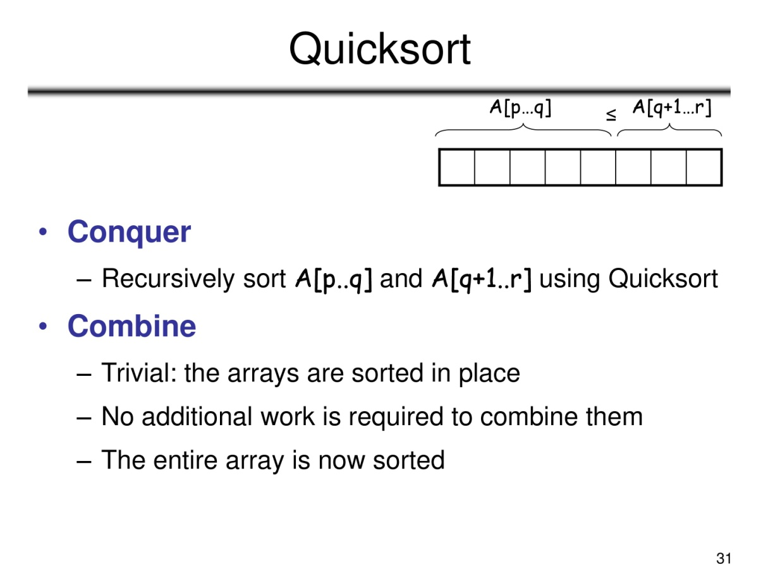

Algorithm: Quick-Sort (A, p, r)
if p < r then
q= Partition (A, p, r)
Quick-Sort (A, p, q-1)
Quick-Sort (A, q + 1, r)

Initially p=1, r=n



